**TASK-1**

* **Demonstrate minimum 15 basic docker command with explanation and screenshot.**

1. [**docker pull**](https://www.edureka.co/blog/docker-commands/#pull) **:-** Pull an image or a repository from a registry

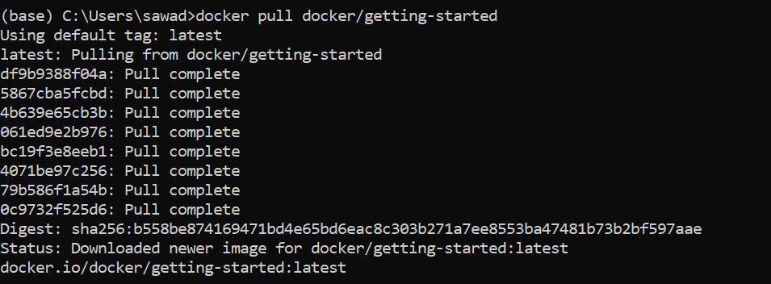

1. [**docker run**](https://www.edureka.co/blog/docker-commands/#run) **:-** Run a command in a new container



1. [**docker ps**](https://www.edureka.co/blog/docker-commands/#ps) **:-** List containers

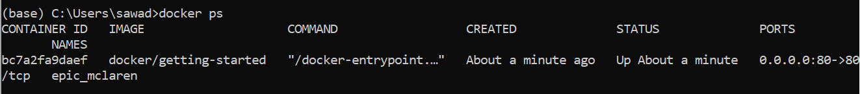

1. [**docker ps -a**](https://www.edureka.co/blog/docker-commands/#psa) **:-**

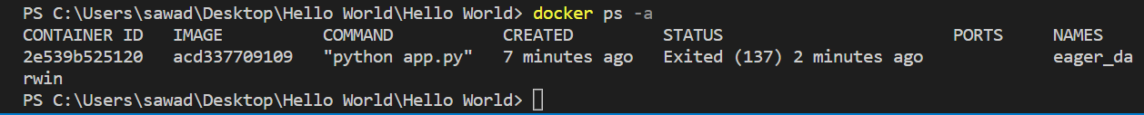

1. [**docker exec**](https://www.edureka.co/blog/docker-commands/#exec) **:-** Run a command in a running container
2. [**docker stop**](https://www.edureka.co/blog/docker-commands/#stop) **:-** Stop one or more running containers

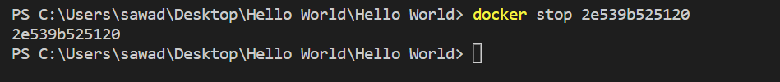

1. [**docker kill**](https://www.edureka.co/blog/docker-commands/#kill) **:-** Kill one or more running containers
2. [**docker commit**](https://www.edureka.co/blog/docker-commands/#commit) **:-** Create a new image from a container’s changes
3. [**docker login**](https://www.edureka.co/blog/docker-commands/#login) **:-** Log in to a Docker registry
4. [**docker push**](https://www.edureka.co/blog/docker-commands/#push) **:-** Push an image or a repository to a registry

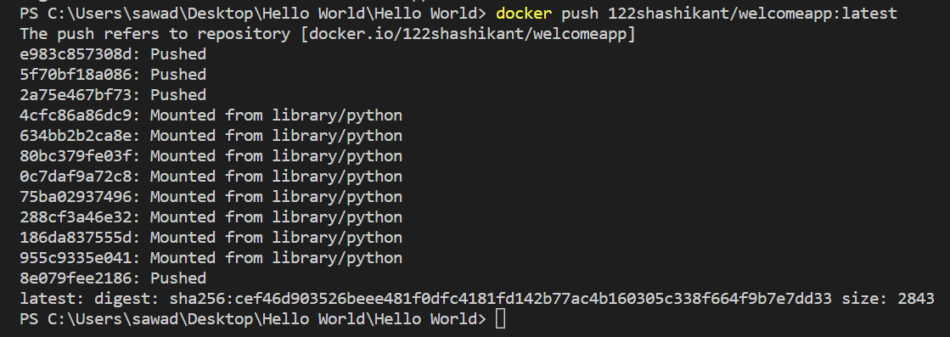

1. [**docker images**](https://www.edureka.co/blog/docker-commands/#images) **:-** List images

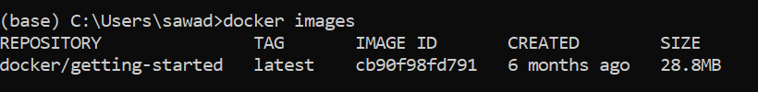

1. [**docker rm**](https://www.edureka.co/blog/docker-commands/#rm) **:-** Remove one or more containers



1. [**docker rmi**](https://www.edureka.co/blog/docker-commands/#rmi) **:-** Remove one or more images



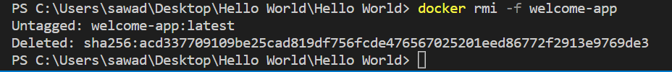

1. [**docker build**](https://www.edureka.co/blog/docker-commands/#build) **:-** Build an image from a Docker file

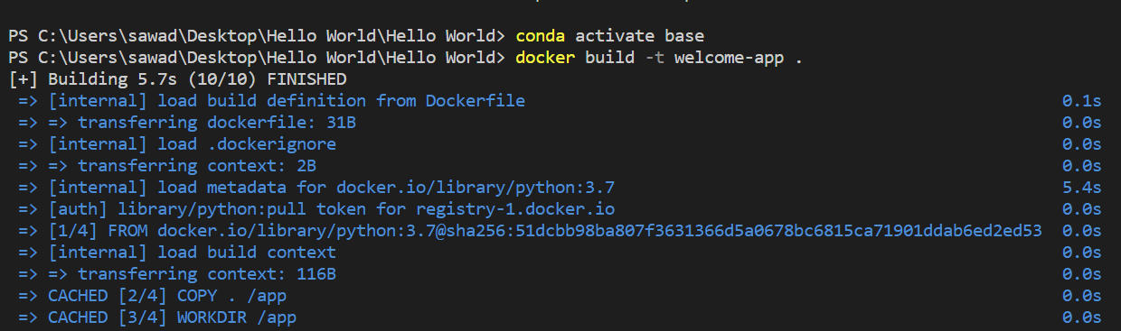

1. **Docker version: -** Show the Docker version information

